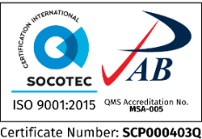
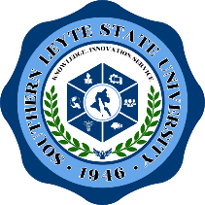
Republic of the Philippines
SOUTHERN LEYTE STATE UNIVERSITY
Main Campus, Sogod, Southern Leyte
website: www.slsuonline.edu.ph
email: slsumaincampus@gmail.com/
op@slsuonline.edu.ph telefax: (053) 577-8299

Bids & Awards Committee

NOTICE OF RESUMPTION OF BIDDING ACTIVITIES
Supply, Delivery & Installation of Sports Equipment
(PB 2021-G&S-11)
Approved Budget for the Contract (ABC) - ₱1,544,000.00

This is to notify all interested parties that the Opening of Bids for the 2nd bidding process for the above-named project will resume on 22 September 2021 at 9:30 in the morning at the AVR Room, CCSIT Building, SLSU Main Campus, Sogod, Southern Leyte.

Bidders who wish to submit bid proposals will be given access to the virtual opening of bids via Zoom.

For guidance and information of all concerned.

Issued this 13th day of September 2021 at SLSU Main Campus, Sogod, Southern Leyte.

Sgd.
MABEL R. CALVA
BAC Chairperson

